**Assignment no 15**

1)

#include<iostream>

#include<math.h>

using namespace std;

class math

{

int a,b,s,d,r,h,c,f;

public:

void get()

{

cout<<"\n enter the value of a and b: ";

cin>>a>>b;

}

void cal()

{

s= sqrt(a);

d= pow(a,b);

r= sin(b);

h= tan(a);

c= ceil(5.7);

f= floor(5.4);

}

void dis()

{

cout<<"\n square root:"<<s;

cout<<"\n power:"<<d;

cout<<"\n sin:"<<r;

cout<<"\n tan:"<<h;

cout<<"\n ceil:"<<c;

cout<<"\n floor:"<<f;

}

};

int main()

{

math m;

m.get();

m.cal();

m.dis();

}

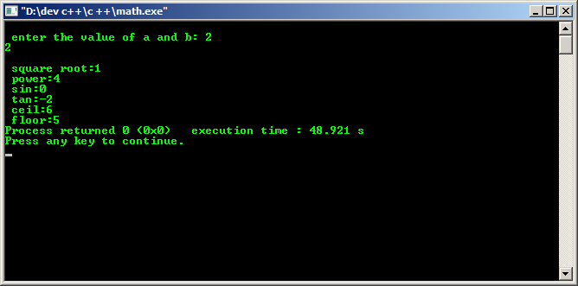

2)

#include<iostream>

#include<math.h>

using namespace std;

class quad

{

int a,b,c,s,d;

float r1,r2;

public:

void get()

{

cout<<"\n enter the value of a and b and c: ";

cin>>a>>b>>c;

}

void cal()

{

d= (b*b) - (4*a*c);

if(d<0)

{

cout<<"\n root is found";

}else

{

r1 = (-b + sqrt(d))/ (2*a);

r2 = (-b - sqrt(d))/ (2*a);

cout<<"\n root1 : "<<r1;

cout<<"\n root2 : "<<r2;

}

}

};

int main()

{

quad q;

q.get();

q.cal();

}

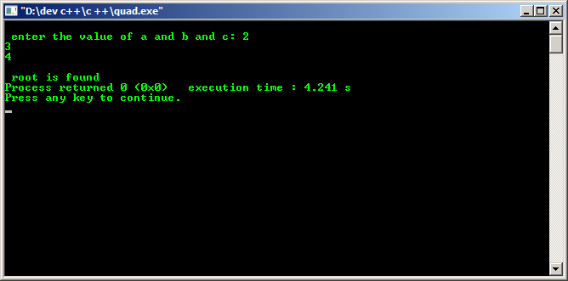

3)

#include<iostream>

#include<string.h>

using namespace std;

int main()

{

char s1[20], s2[20];

cout<<"enter the string to find the length:";

cin>>s1;

cout<<" length:"<<strlen(s1);

strcpy(s2,s1);

cout<<"\n copied string is : "<<s2;

cout<<"\n enter 2 strings to be concatinated:";

cin>>s1>>s2;

strcat(s1,s2);

cout<<"\n concatinated string : "<<s1<<endl;

cout<<"\n enter 2 strings to be compaired :";

cin >>s1>>s2;

int i = strcmp(s1,s2);

if(i==0)

cout<<s1<<"is less than "<<s2<<endl;

else

cout<<s1<<"is greater than "<<s2<<endl;

cout<<"\n enter the string to change to lower case :";

cin>>s1;

cout<<"\n lower case of the given string : "<<strlwr(s1);

}

